**Name: Muhammad Usman Zaib**

**Registration Number: 402104**

**Assignment No: 3**

**Total Number of Medium Task Solved = 22**

**Total Number of Hard Task Solved = 3**

**MEDIUM TASKS:**

**1)Write a Function**

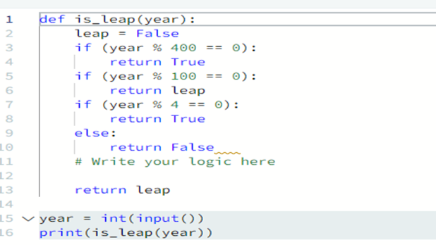

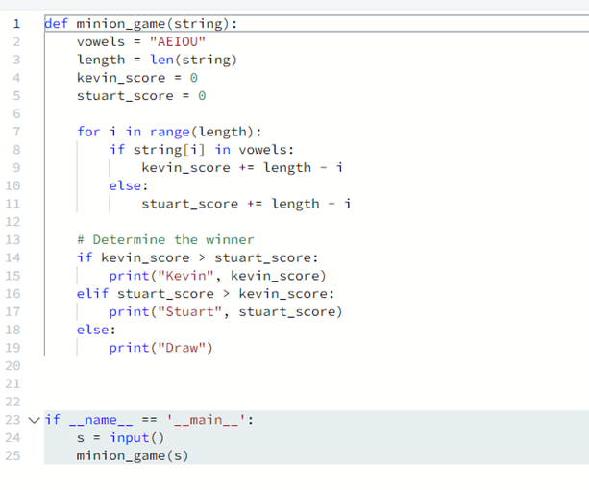**2)The Minion Game**

3) **Merge the Tool**

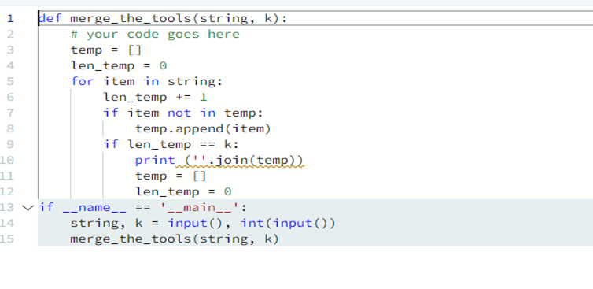

1. 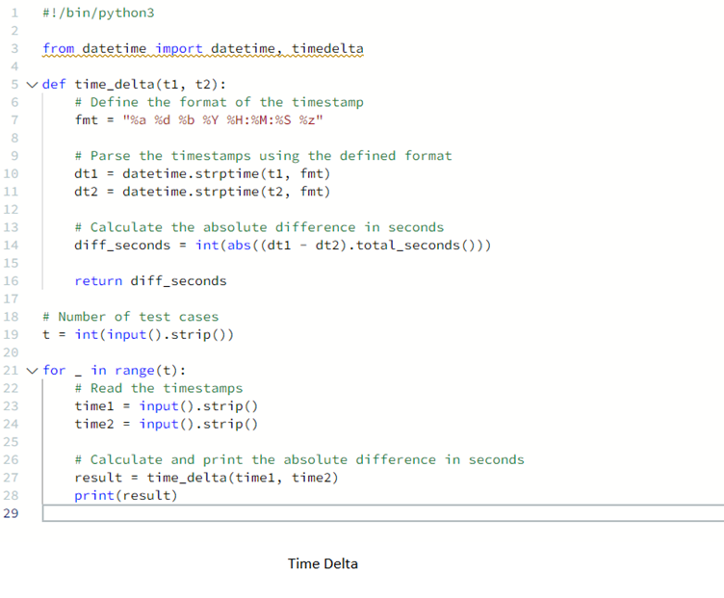**Time Delta**
2. **Find angle MBC.**

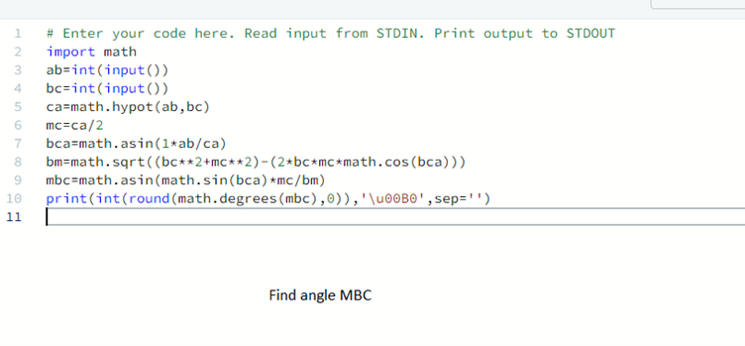

1. **No idea**

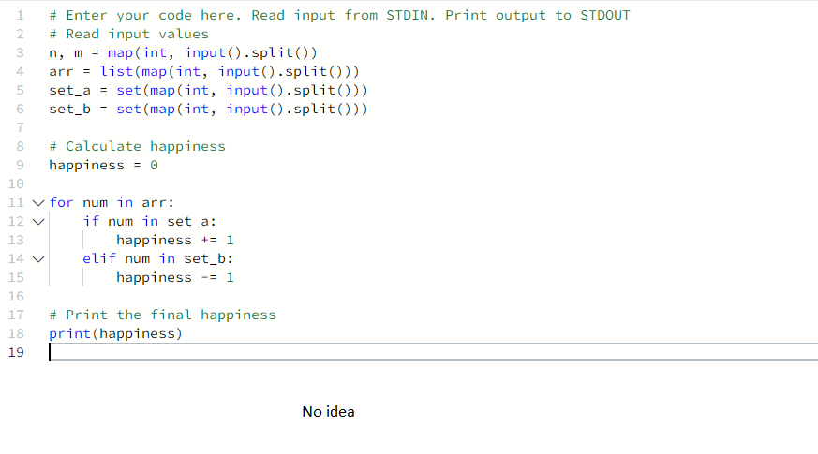

1. **Word order**

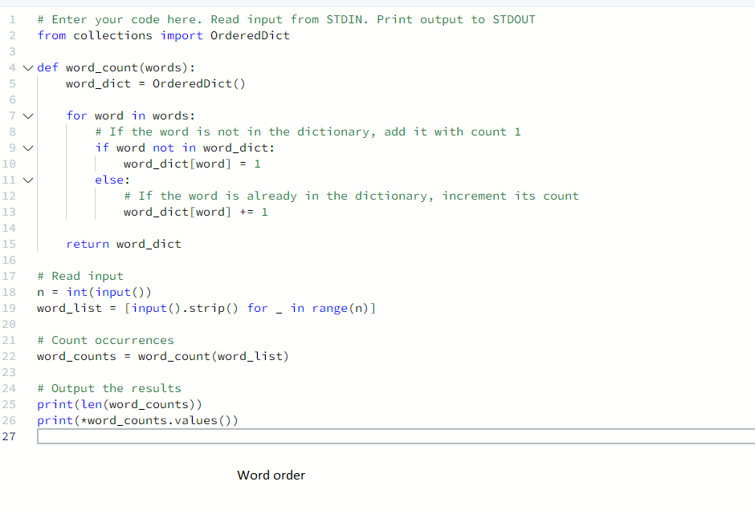

1. **Compress the string.**

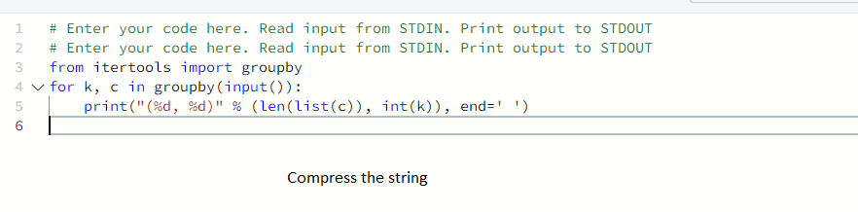

1. **Company logo**

1. **Piling up**

1. **Triangular quest 2**

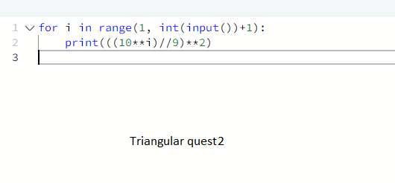

1. **Iterables & Iterators**

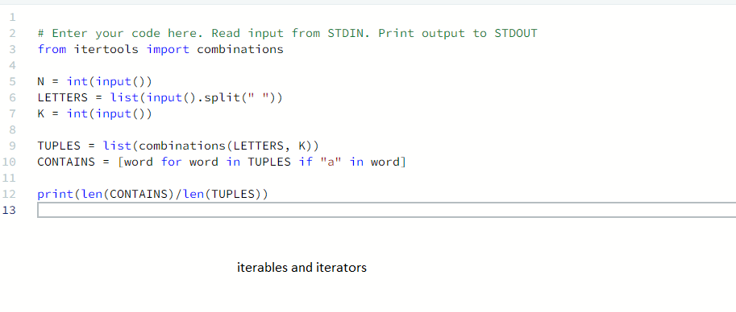

1. **Triangular quest**

1. **A screenshot of a computer program

   Description automatically generatedClasses: dealing with complex number**
2. **Athlete sort**

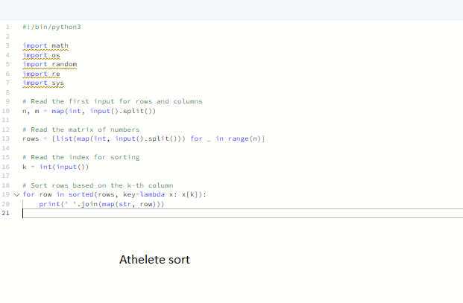

1. **Ginortx**

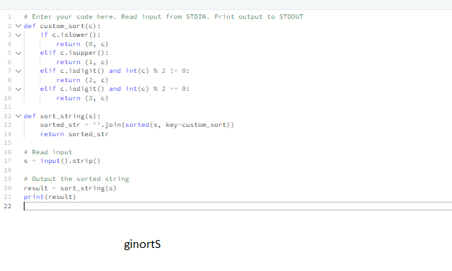

1. **Validating Email address with a filter**

1. **Reduce function.**

1. **Regrex substitution**

1. **Validating Credit card number**

1. **Word score**

1. **Default argument**

**Hard task:**

1. Maximize it

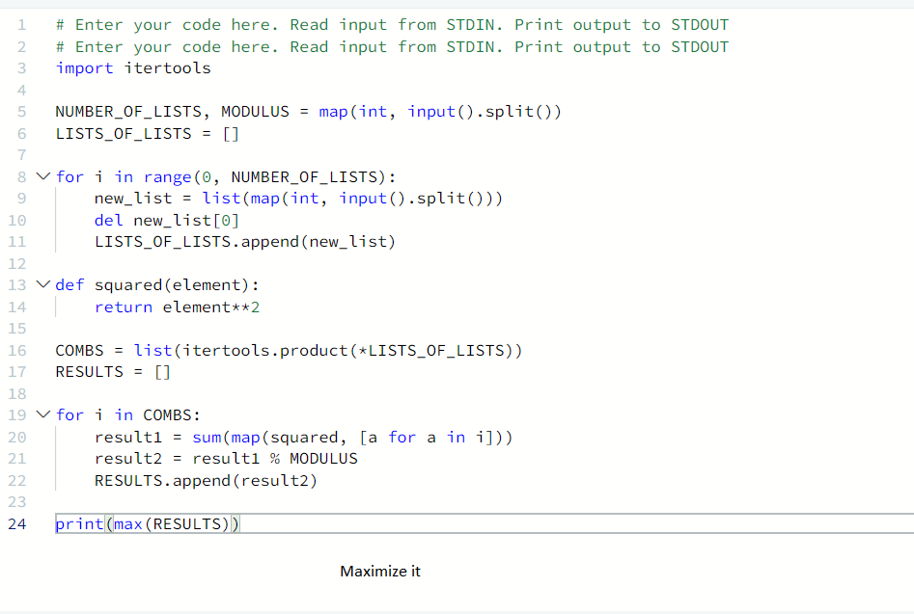

1. Validating postal codes

1. Matrix script

All Tasks were Completed on Hacker Net

MEDIUM

**HARD**

